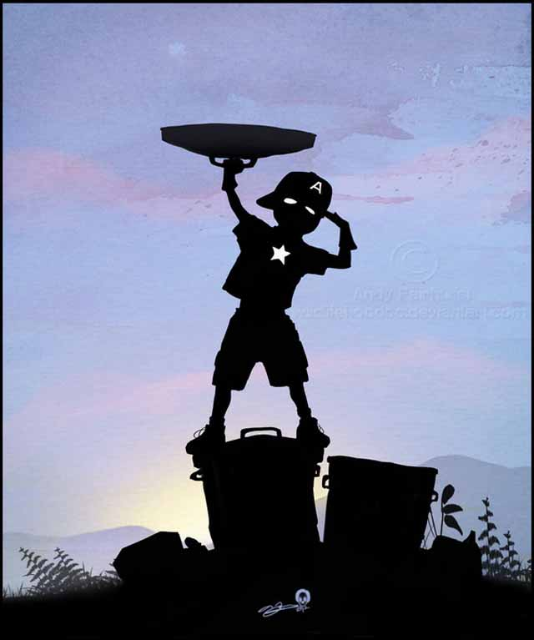
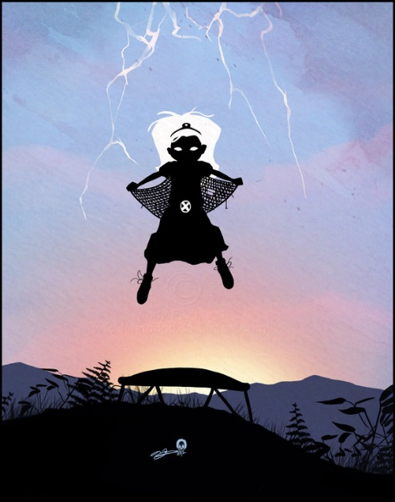
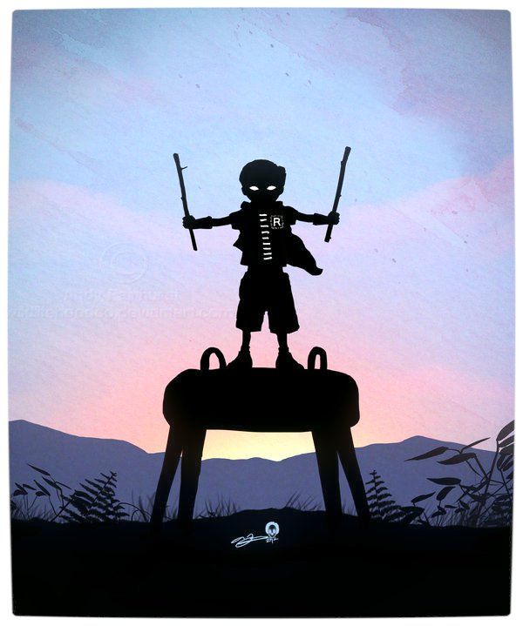
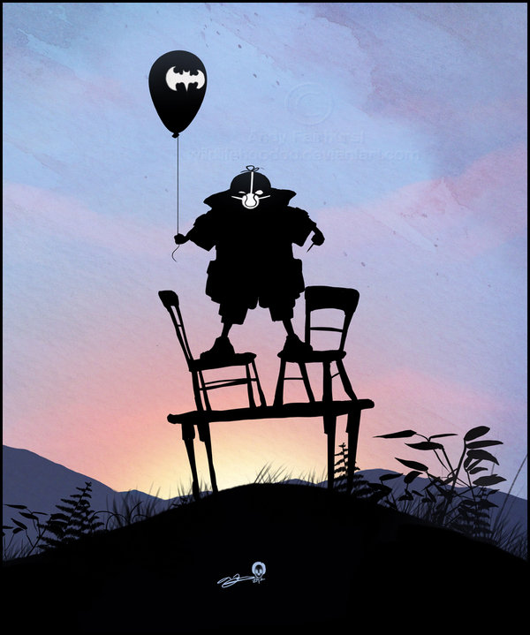
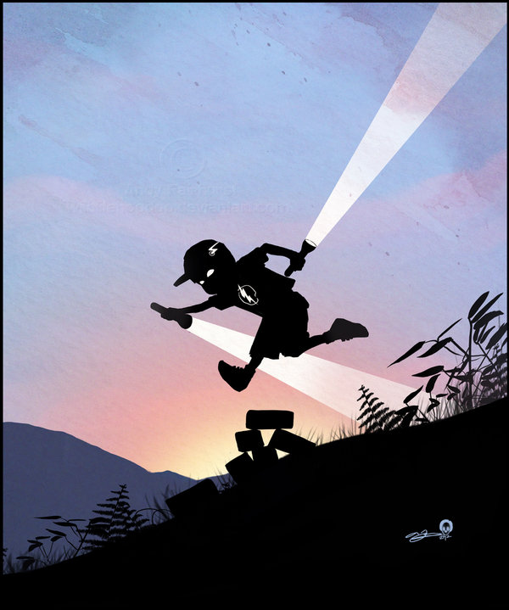
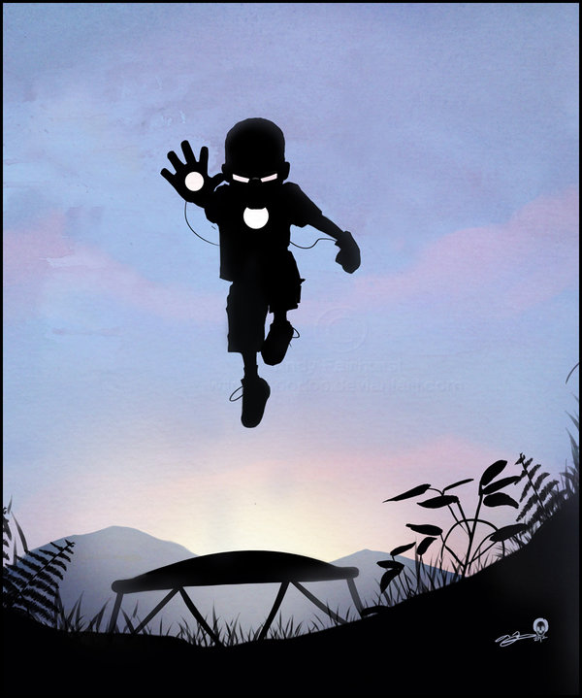
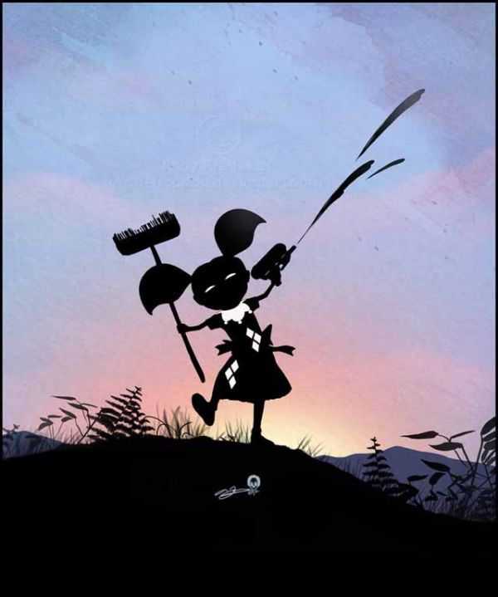
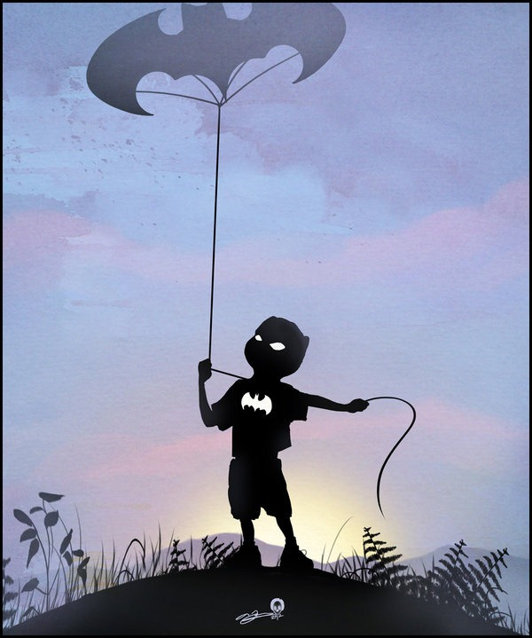
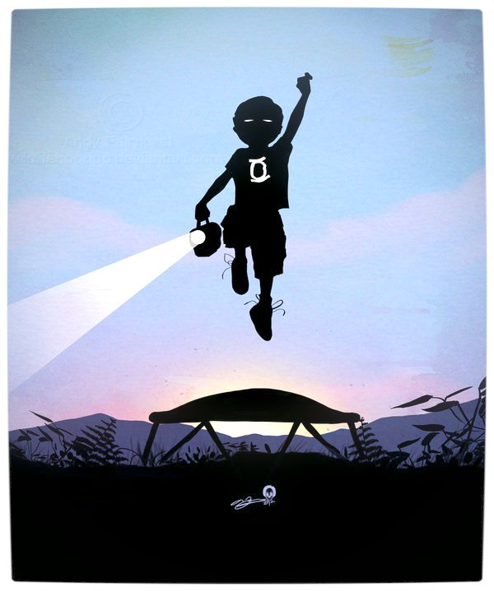
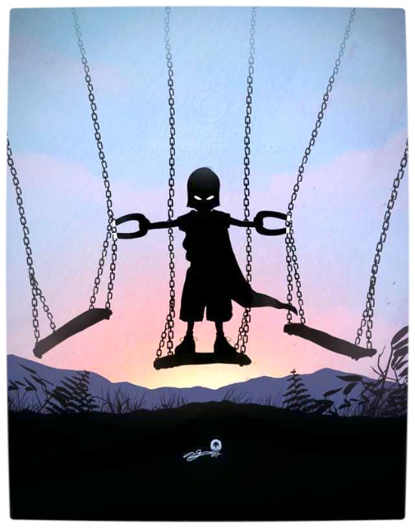
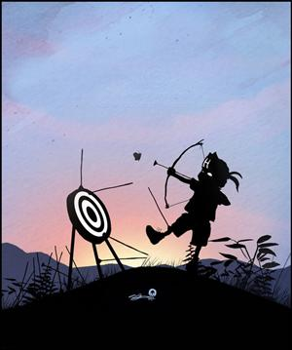
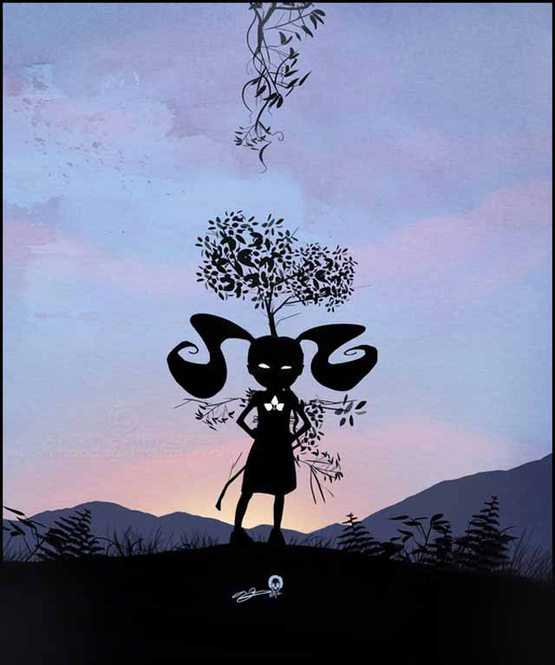
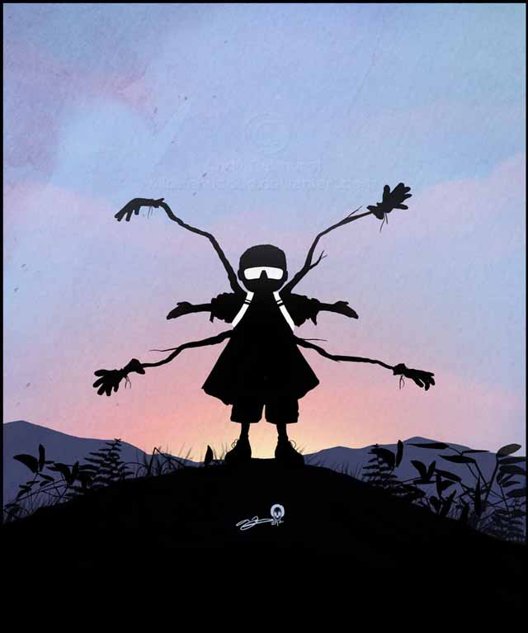
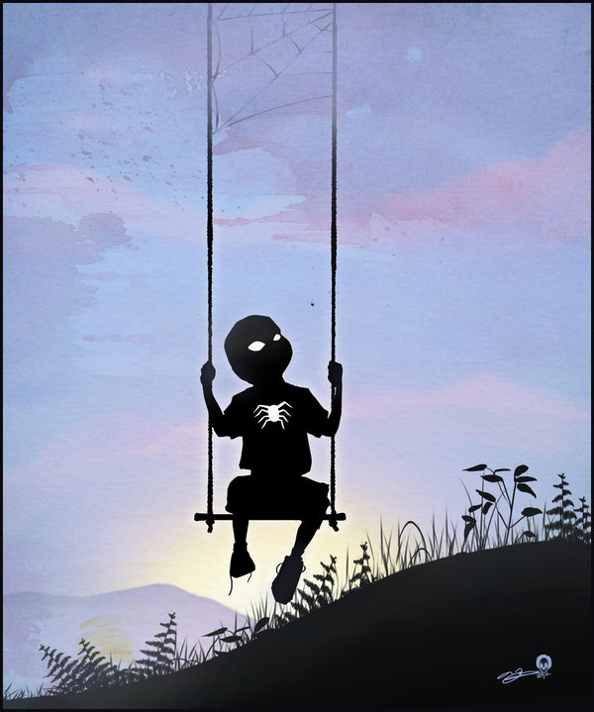
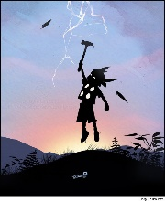
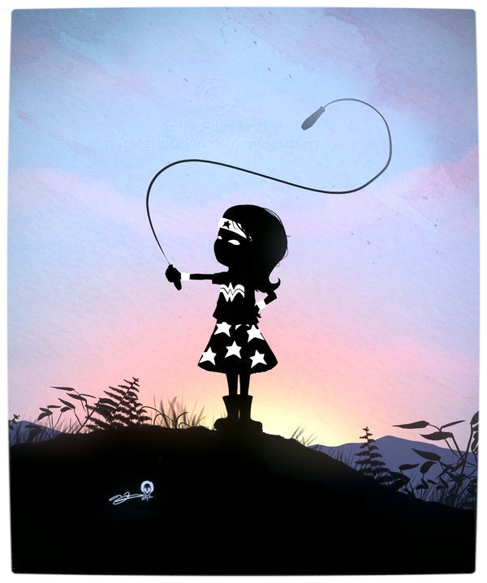

The Hero’s Quest
The Tale of A Tales

“Archetypes are typical images, characters, narrative designs, themes, and other literary phenomena which are present in all literature, and so provide the basis for study of its interconnectedness.”

Joseph Campbell’s The Hero with a Thousand Faces

In 1949, Joseph Campbell (1904-1987) made a big splash in the field of mythology with his book The Hero with a Thousand Faces. This book built on the pioneering work of German anthropologist Adolph Bastian (1826-1905), who first proposed the idea that myths from all over the world seem to be built from the same “elementary ideas.” Swiss psychiatrist Carl Jung (1875-1961) named these elementary ideas “archetypes,” which he believed to be the building blocks not only of the unconscious mind, but of a collective unconscious. In other words, Jung believed that everyone in the world is born with the same basic subconscious model of what a “hero” is, or a “mentor” or a “quest,” and that's why people who don't even speak the same language can enjoy the same stories. Jung developed his idea of archetypes mostly as a way of finding meaning within the dreams and visions of the mentally ill.

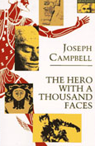
Campbell's contribution was to take this idea of archetypes and use it to map out the common underlying structure behind religion and myth. He proposed this idea in The Hero with a Thousand Faces, which provides examples from cultures throughout history and all over the world. Campbell eloquently argues that all stories are fundamentally the same story, which he named the “Hero's Journey,” or the “monomyth.” This sounds like a simple idea, but it suggests an incredible ramification, which Campbell summed up with his adage “All religions are true, but none are literal.” That is, he concluded that all religions are really containers for the same essential truth, and the trick is to avoid mistaking the wrappings for the diamond.
Lucas had already written two drafts of Star Wars when he rediscovered Joseph Campbell's The Hero with a Thousand Faces in 1975 (having read it years before in college). This blueprint for “The Hero's Journey” gave Lucas the focus he needed to draw his sprawling imaginary universe into a single story.

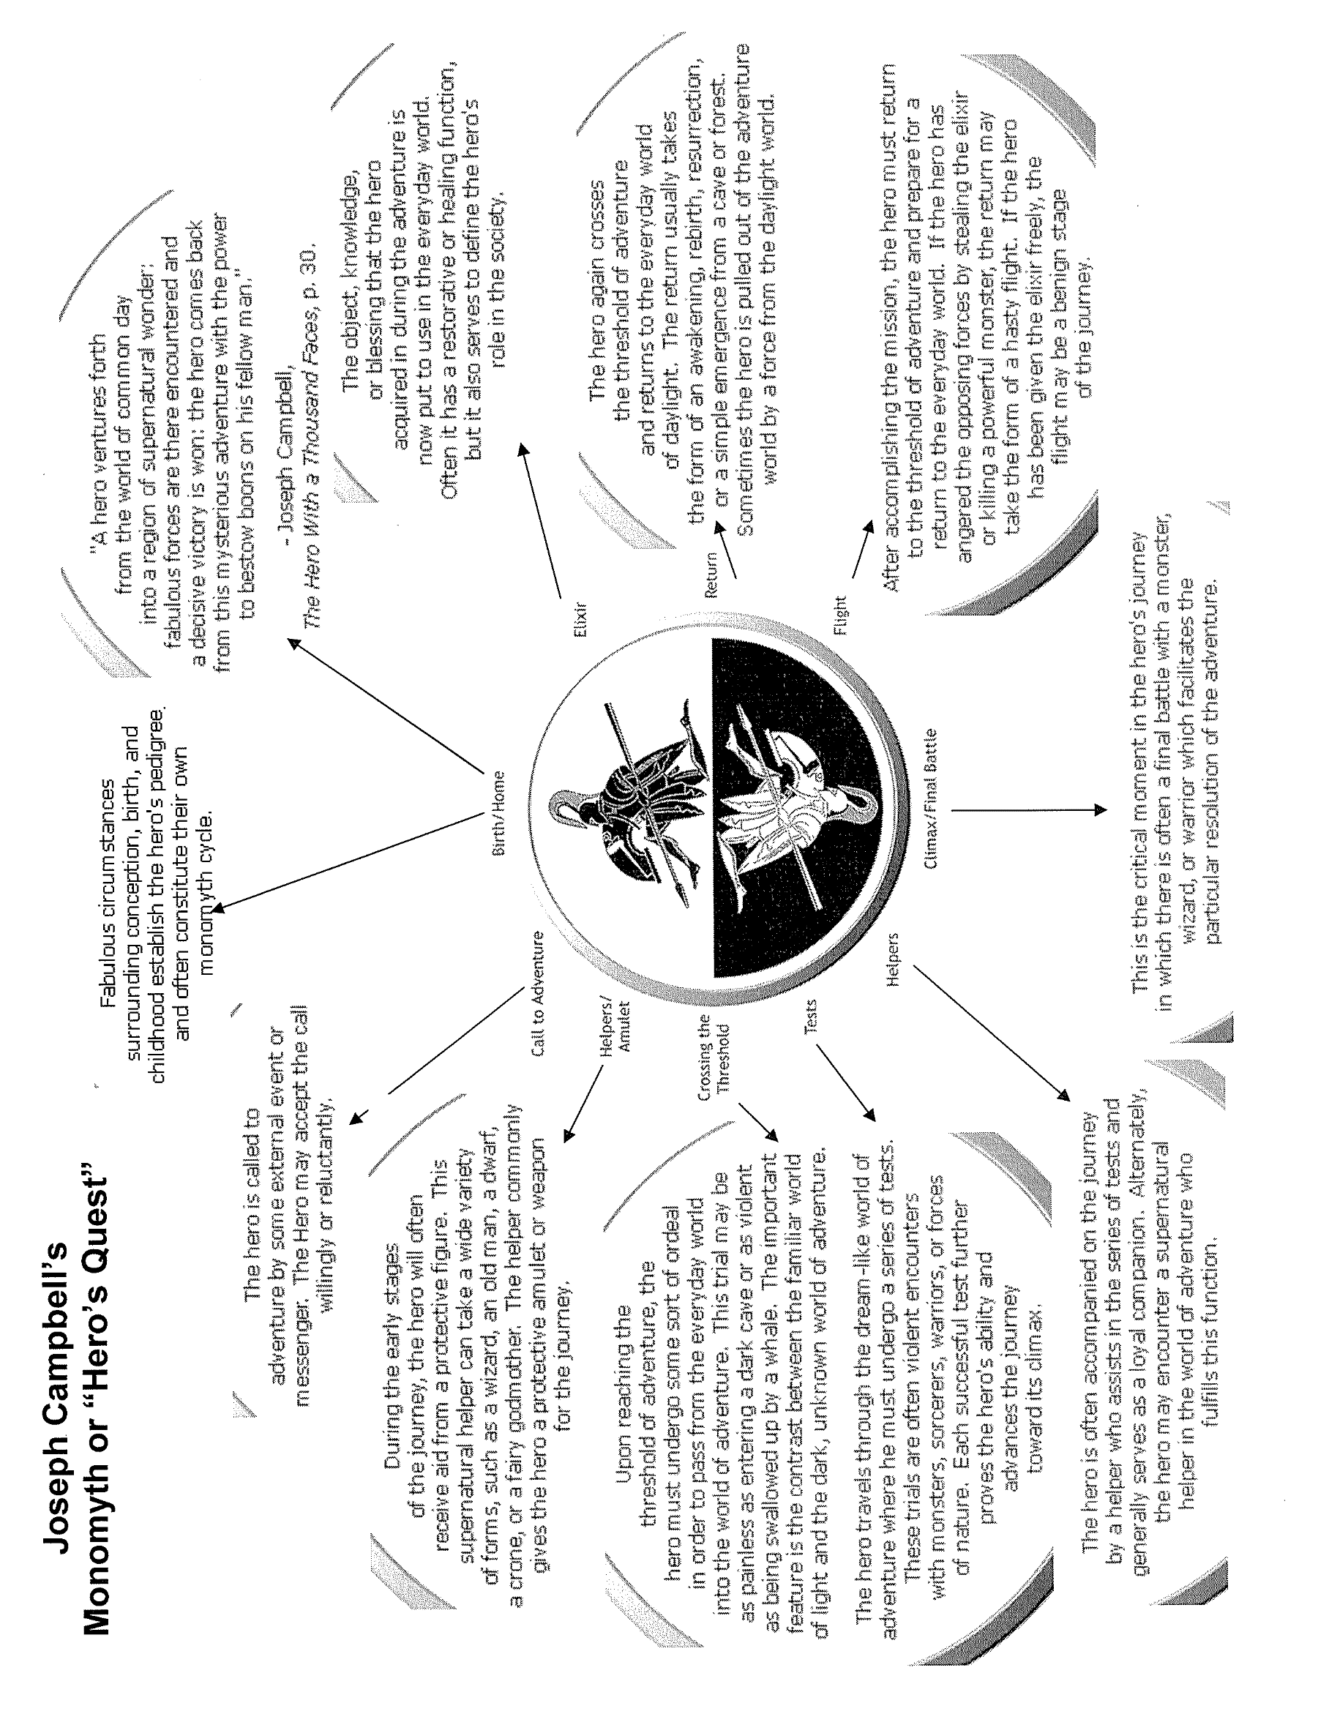
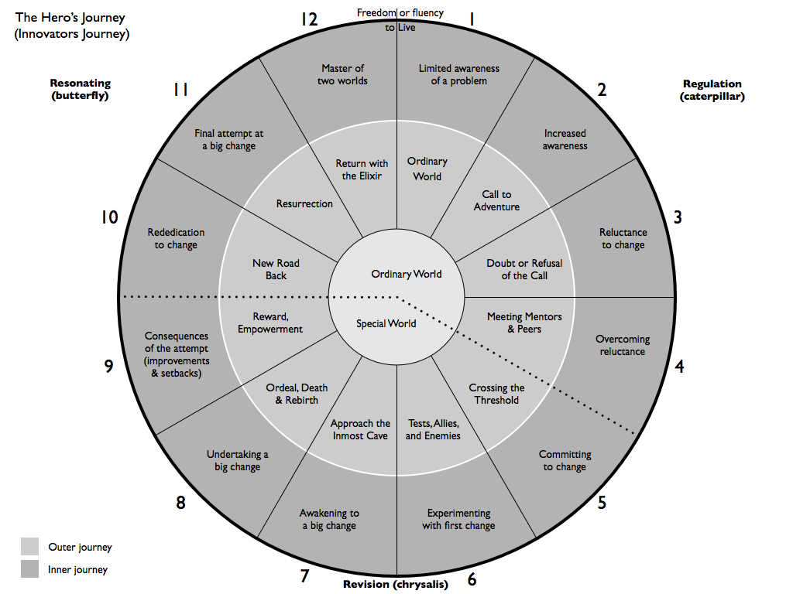
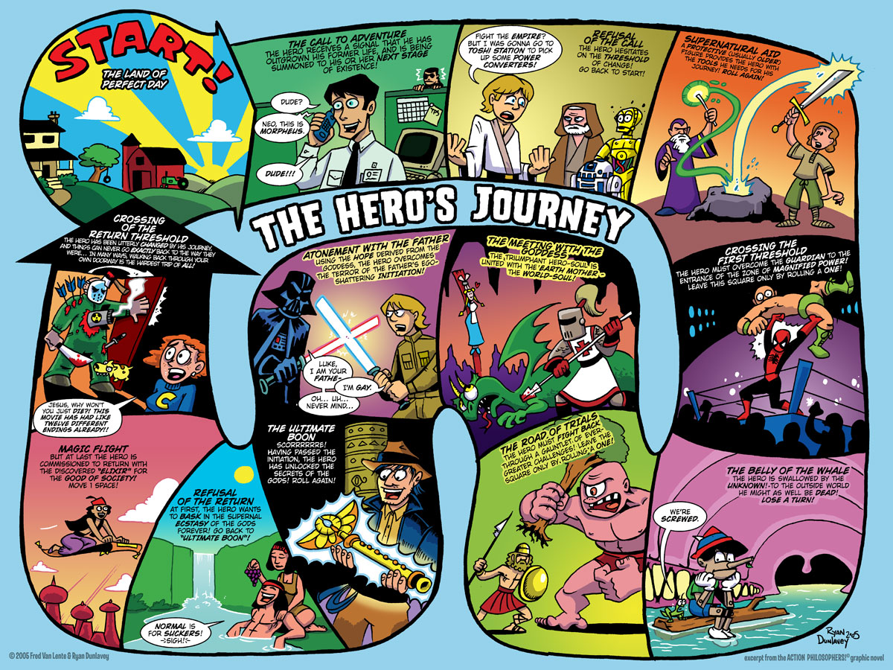
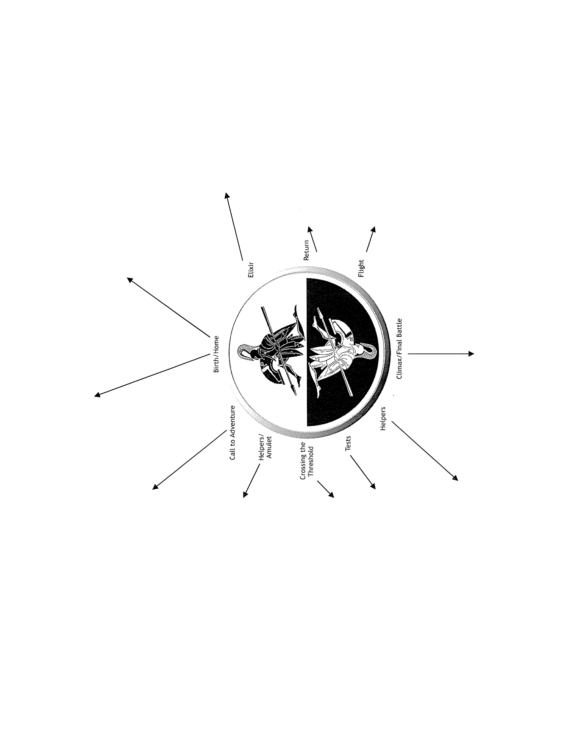
Stardust
Applying the Hero’s Quest Model

Campbell’s Model | Description | Star Wars Example | Stardust Example
Ordinary World | A “normal” person living an ordinary life. | Skywalker bored on remote farm. His parents are assumed dead and feel incomplete.
Call To Adventure | The call to adventure is the point in a person's life when they are first given notice that everything is going to change, whether they know it or not. | Luke finds Leia’s plea for help in R2D2.
Refusal of the Call | Often when the call is given, the future hero refuses to heed it. This may be from a sense of duty or obligation, fear, insecurity, a sense of inadequacy, or any of a range of reasons that work to hold the person in his or her current circumstances. | Luke won’t take up Obi’s challenge because uncle and aunt need him.
Meeting the Mentor | Once the hero has committed to the quest, consciously or unconsciously, his or her guide and magical helper appears, or becomes known. | Luke puts himself in hands of Obi and learns about The Force.
Campbell’s Model | Description | Star Wars Example | Stardust Example
Crossing The First Threshold | This is the point where the person actually crosses into the field of adventure, leaving the known limits of his or her world and venturing into an unknown and dangerous realm where the rules and limits are not known. | Luke takes up challenge when Stormtroopers barbecue aunt and uncle.
Tests, Allies, Enemies | The road of trials is a series of tests, tasks, or ordeals that the person must undergo to begin the transformation. Often the person fails one or more of these tests, which often occur in threes. | They meet Han, Wookie and Jabba.
Approach to the Inmost Cave | The Hero approaches a challenge. They are put in a situation that could result in their demise. | Adventures which culminate in breakout from Deathstar.
Supreme Ordeal | The event, conflict, fight, epic battle occurs. | Series of adventures in Deathstar including near-death in garbage compactor.
Reward (Seizing the Sword) | The hero triumphs. | Luke and Co escape with information about Deathstar destruction, but lose Obi-Wan
Campbell’s Model | Description | Star Wars Example | Stardust Example
Road Back | The returns to his regular world, changed by the events that have happened to him/her. | Worst not over. Deathstar is in range of rebel base and must be destroyed.
Resurrection | The force thought vanquished returns in some way. | Luke trusts the force and sacrifices old part of personality – his dependence on machines.
Return with Elixir | The story ends. There is usually great rejoicing. | Luke and friends decorated as heroes. Luke’s internal elixir is new self-knowledge and control of the Force.

Random Observations
or Questions I still want Answered
RADIO PLAY Planning
Putting Campbell’s Theory into Practice

Campbell’s Model | Description | RADIO PLAY VERSION
Ordinary World | A “normal” person living an ordinary life.
Call To Adventure | The call to adventure is the point in a person's life when they are first given notice that everything is going to change, whether they know it or not.
Refusal of the Call | Often when the call is given, the future hero refuses to heed it. This may be from a sense of duty or obligation, fear, insecurity, a sense of inadequacy, or any of a range of reasons that work to hold the person in his or her current circumstances.
Meeting the Mentor | Once the hero has committed to the quest, consciously or unconsciously, his or her guide and magical helper appears, or becomes known.
Campbell’s Model | Description | RADIO PLAY VERSION
Crossing The First Threshold | This is the point where the person actually crosses into the field of adventure, leaving the known limits of his or her world and venturing into an unknown and dangerous realm where the rules and limits are not known.
Tests, Allies, Enemies | The road of trials is a series of tests, tasks, or ordeals that the person must undergo to begin the transformation. Often the person fails one or more of these tests, which often occur in threes.
Approach to the Inmost Cave | The Hero approaches a challenge. They are put in a situation that could result in their demise.
Supreme Ordeal | The event, conflict, fight, epic battle occurs.
Reward (Seizing the Sword) | The hero triumphs.
Campbell’s Model | Description | RADIO PLAY VERSION
Road Back | The returns to his regular world, changed by the events that have happened to him/her.
Resurrection | The force thought vanquished returns in some way.
Return with Elixir | The story ends. There is usually great rejoicing.

Constructive Criticism
Feedback from Teacher or Peers

