Personal Response to Text Assignment:
Decoding Visual Text
Suggested Time: 45 to 60 minutes

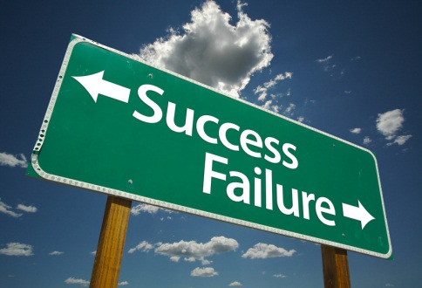
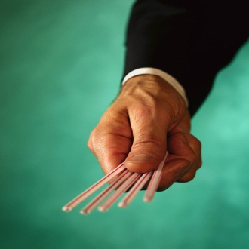

Introduction:

As English Language Arts students, it is imperative that we can make meaning of all forms of text. We are well-versed on how to accomplish this when presented with written language; yet, further work needs to be done in solidifying our understanding of visual language. This includes a set of practices by which images can be used to communicate concepts. Just as people can ‘verbalize’ their thinking, they can ‘visualize’ it. The elements in an image represent concepts in a spatial context, rather than the linear form used for words. Speech and visual communication are parallel and usually interdependent means by which humans exchange information.

The Assignment:

Please refer to the photographs you were previously provided (and which are now displayed on the SmartBoard). Reflect on the visuals before you. Though they may be out of context, they are still representative of greater ideas that are interpretative.

- What do you see?

- What structural units are at play?

- What feeling or atmosphere is created?

- Consider the “action.” What is happening in the present, in the past, and project what may occur in the future?

Now that you have solidified your understandings of the visual at hand, the next step is to extend your understanding in a Personal Response that is creative in nature. There are many different ways of potentially interpreting this picture but you must always link it back to the topic:

Does having a choice mean making compromises?
In your writing, you must:

- Use a prose form
- Capture the overriding feeling pervasive to the visual
- Connect your response back to the topic (Does having a choice mean making a compromise?)
- Plan, edit, and proof-read

Initial Planning:

State the title of the photograph you will be using as the inspiration for your piece:

______________________________________________________________________________

Briefly identify the central idea that is most relevant to what you will explore:

______________________________________________________________________________
______________________________________________________________________________
______________________________________________________________________________
______________________________________________________________________________
______________________________________________________________________________
______________________________________________________________________________

Outline the manner in which you intend to explore the central idea in your own piece:

______________________________________________________________________________
______________________________________________________________________________
______________________________________________________________________________
____________________________________________________________________________________________________________________________________________________________
______________________________________________________________________________
______________________________________________________________________________
______________________________________________________________________________
______________________________________________________________________________
______________________________________________________________________________
______________________________________________________________________________

